

AI-POWERED ENTERPRISE KNOWLEDGE ASSISTANT USING RETRIEVAL-AUGMENTED GENERATION (RAG) AND NATURAL LANGUAGE PROCESSING
A CAPSTONE PROJECT REPORT
Submitted in partial fulfilment of the requirements
for the Course of
DSA0308 - NATURAL LANGUAGE PROCESSING
to the award of the degree of
BACHELOR OF TECHNOLOGY
IN
COMPUTER SCIENCE AND ENGINEERING (CSE)
Submitted by
V. Nagendra (192425091)

Under the Supervision of
Dr. T Kumaragurubaran

SIMATS ENGINEERING
Saveetha Institute of Medical and Technical Sciences
Chennai–602105
SEPTEMBER 2026


SIMATS ENGINEERING
Saveetha Institute of Medical and Technical Sciences
Chennai–602105
BONAFIDE CERTIFICATE
This is to certify that the Capstone Project entitled "Ai-powered Enterprise Knowledge Assistant using Retrieval-augmented Generation (RAG) and Natural Language Processing" has been carried out by B. Rajesh (192472165), V. Nagendra (192425091) and C. Sandeep (192472368) under the supervision of Dr. T. Kumaragurubaran and is submitted in partial fulfilment of the requirements for the current semester of the B. Tech Computer Science and Engineering program at Saveetha Institute of Medical and Technical Sciences, Chennai.
COURSE COORDINATOR | COURSE FACULTY / GUIDE
Dr. Devi  Professor  Department of CSE  SIMATS Engineering | Dr. T. Kumaragurubaran  Professor  Department of CSE  SIMATS Engineering


SIMATS ENGINEERING
Saveetha Institute of Medical and Technical Sciences
Chennai–602105
DECLARATION
We, B. Rajesh (192472165), V. Nagendra (192425091) and C. Sandeep (192472368) of the Department of B. Tech Computer Science and Engineering (CSE), SIMATS Engineering, Saveetha Institute of Medical and Technical Sciences, Chennai, hereby declare that the Capstone Project Work entitled "Ai-powered Enterprise Knowledge Assistant using Retrieval-augmented Generation (RAG) and Natural Language Processing" is the result of our own Bonafide efforts.
To the best of our knowledge, the work presented herein is original, accurate, and has been carried out in accordance with the principles of engineering ethics and academic integrity. All sources, references, data, and other materials used in the project have been appropriately acknowledged.
We further declare that the data, results, analysis, and findings presented in this report have not been fabricated, falsified, or manipulated. Any external tools, software, datasets, computational resources, or AI-assisted tools used during the project have been appropriately disclosed. We confirm that all applicable ethical, academic, institutional, and professional requirements have been duly followed throughout the planning, execution, analysis, and documentation of the project.
Place:
Date:
Signature of the Students with Names
B. Rajesh (192472165)
V. Nagendra (192425091)
C. Sandeep (192472368)
INDIVIDUAL CONTRIBUTION STATEMENT
(Mandatory for all team projects)
Student Name / Register No. | Specific Responsibilities | Design & Development Contribution | Testing & Analysis Contribution | Report Contribution | Approx. Contribution (%)
B. Rajesh (192472165) | Document ingestion from PDF/DOCX/HTML/wiki sources; text cleaning and normalization; chunking strategy; metadata tagging | Built document-loader and pre-processing pipeline (Module 1); designed chunk size/overlap and metadata schema | Validated parsing accuracy and chunk-boundary correctness across document types | Ch. 1, Ch. 2, Ch. 3 (Module 1 sections), Ch. 4 (Module 1 results), appendices | 34%
V. Nagendra (192425091) | Embedding generation; vector-index design; hybrid semantic + keyword retrieval; re-ranking of retrieved chunks | Built the retrieval engine (Module 2): embedding pipeline, FAISS/Chroma vector index, hybrid retrieval and re-ranking logic | Evaluated retrieval precision/recall, MRR and latency benchmarking on the query test set | Ch. 1, Ch. 2, Ch. 3 (Module 2 sections), Ch. 4 (Module 2 results), Ch. 5 | 33%
C. Sandeep (192472368) | Prompt engineering; LLM integration for answer generation; conversational assistant interface; source-citation logic | Built the RAG orchestration and QA layer (Module 3): context assembly, prompt construction, answer synthesis with citations | Evaluated answer relevance, faithfulness and hallucination rate of generated responses | Ch. 1, Ch. 2, Ch. 3 (Module 3 sections), Ch. 4 (Module 3 results), Ch. 5, appendices | 33%
TOTAL |  |  |  |  | 100%

ABSTRACT
The AI-Powered Enterprise Knowledge Assistant using Retrieval-Augmented Generation (RAG) and Natural Language Processing is aimed at helping employees retrieve accurate, cited answers from an organization's scattered internal documentation instead of manually searching PDFs, wikis, and shared drives. Enterprise knowledge is typically distributed across policy manuals, technical specifications, onboarding wikis, and compliance guides, and conventional keyword search or standalone chatbots either return long documents that must be read manually or generate fluent but ungrounded answers that risk hallucination. To address this, the proposed system ingests heterogeneous enterprise documents, cleans and semantically chunks them, and indexes them as vector embeddings in a vector database. A hybrid retrieval engine combining semantic and keyword search retrieves the most relevant chunks for a natural-language query, and a large-language-model-based question-answering layer synthesizes a concise, source-cited answer grounded strictly in the retrieved content. The system is organized into three core modules: Knowledge Acquisition and Document Processing, Retrieval-Augmented Information Retrieval Engine, and AI-Powered Question Answering and Knowledge Assistance, integrated through a conversational assistant interface. The expected engineering outcome is a reliable, extensible enterprise knowledge assistant that reduces information-search time, improves answer traceability through citations, and demonstrates practical integration of NLP, vector retrieval, and generative AI for real-world enterprise knowledge management.

Keywords
Retrieval-Augmented Generation; Natural Language Processing; enterprise knowledge management; vector embeddings; semantic search; large language models; question answering

TABLE OF CONTENTS
Sl. No. | Title | Page No.
i | CERTIFICATE FROM THE SUPERVISOR / BONAFIDE CERTIFICATE | ii
ii | DECLARATION BY THE CANDIDATES | iii
iii | INDIVIDUAL CONTRIBUTION STATEMENT | iv
iv | ABSTRACT | v
v | LIST OF FIGURES | vii
vi | LIST OF TABLES | viii
vii | LIST OF ABBREVIATIONS / SYMBOLS | ix
1 | CHAPTER 1: Introduction and Engineering Problem | 1
2 | CHAPTER 2: Literature Review and Existing Solutions | 4
3 | CHAPTER 3: Engineering Design & Trade-offs, Sustainability, Ethics, Safety, Risk & Security | 6
4 | CHAPTER 4: Implementation, Testing & Results, Project Management | 11
5 | CHAPTER 5: Conclusion & Reflection | 16
 | References | 20
 | Appendices | 22

LIST OF FIGURES
Figure No. | Figure Name | Page No.
Figure 1 | Sample enterprise document corpus after ingestion and chunking | 5
Figure 2 | Proposed system architecture of the Enterprise Knowledge Assistant | 8
Figure 3 | Document-to-vector processing pipeline | 9
Figure 4 | Sample output of the Enterprise Knowledge Assistant interface | 13
Figure 5 | Retrieval and answer-generation evaluation results | 14
LIST OF TABLES
Table No. | Table Name | Page No.
Table 1 | Stakeholder / User Requirements | 6
Table 2 | Functional and Non-Functional Requirements | 6
Table 3 | Constraints and Applicable Standards | 7
Table 4 | Design Specifications | 7
Table 5 | Alternative Solutions Evaluation | 8
Table 6 | Trade-off Analysis | 9
Table 7 | Sustainability, Ethics, Safety and Security Evidence | 10
Table 8 | Risk Register | 10
Table 9 | Tools / Software / Equipment | 11
Table 10 | Test Plan and Verification | 13
Table 11 | Results / Key Outcomes | 14
Table 12 | Objective Achievement | 15
Table 13 | Project Roles | 15
Table 14 | Project Budget | 16
LIST OF ABBREVIATIONS / SYMBOLS
Abbreviation / Symbol | Description | Unit
AI | Artificial Intelligence | —
NLP | Natural Language Processing | —
RAG | Retrieval-Augmented Generation | —
LLM | Large Language Model | —
API | Application Programming Interface | —
UI | User Interface | —
MRR | Mean Reciprocal Rank | —
RAM | Random Access Memory | GB
n | Number of query/answer pairs used in evaluation | queries

CHAPTER 1
INTRODUCTION AND ENGINEERING PROBLEM
1.1 Background
Modern organizations generate and store enormous volumes of internal knowledge across policy manuals, standard operating procedures, onboarding wikis, product specifications, compliance guidelines, and engineering documentation. Employees routinely need quick, accurate answers drawn from this material — for example, a reimbursement rule, an API rate limit, or a data-retention policy — but this knowledge is typically dispersed across PDFs, Word documents, wikis, and shared drives in inconsistent formats.
Conventional enterprise search tools return whole documents ranked by keyword match, leaving the employee to read through lengthy files to locate the relevant passage. Purely generative AI chatbots, on the other hand, can answer fluently but are not grounded in the organization's actual documents, which creates a risk of hallucinated or outdated answers.
Retrieval-Augmented Generation (RAG) addresses this gap by combining a retrieval component, which finds the most relevant document chunks for a query using vector-based semantic search, with a generative language model that composes a natural-language answer strictly from the retrieved content. This project applies RAG and NLP techniques to build an Enterprise Knowledge Assistant that ingests an organization's internal documents and answers employee questions with concise, source-cited responses.
1.2 Need for the Project
- Enterprise knowledge is fragmented across multiple document formats and repositories, making manual search slow and inconsistent.
- Keyword-based enterprise search returns whole documents rather than direct answers, increasing the time employees spend reading.
- General-purpose LLM chatbots are not grounded in company-specific documents and can produce inaccurate or outdated answers.
- New employees and cross-department staff often lack knowledge of where specific policies or technical details are documented.
- An integrated retrieval-and-generation platform can substantially reduce the time to locate and act on internal information.
Stakeholders affected by this problem include employees across departments (HR, Finance, IT, Engineering, Legal & Compliance), new-hire onboarding teams, knowledge-management administrators, and department heads responsible for maintaining accurate documentation.
1.3 Problem Statement
The engineering problem is to design and implement an integrated enterprise knowledge assistant that can ingest heterogeneous internal documents, clean and semantically chunk them, generate and index vector embeddings, retrieve the most relevant chunks for a natural-language employee query using hybrid semantic and keyword search, and generate a concise, accurate, source-cited answer using a large language model constrained to the retrieved context.
The problem involves interacting requirements related to document-parsing accuracy, chunking granularity, retrieval precision, answer faithfulness (avoiding hallucination), response latency, and responsible handling of internal/confidential enterprise data.
1.4 Project Aim
To design and develop an AI-powered enterprise knowledge assistant that combines document processing, retrieval-augmented information retrieval, and NLP-based question answering to deliver accurate, cited answers from an organization's internal knowledge base.
1.5 Project Objectives
- To collect and pre-process enterprise documents in PDF, DOCX, HTML and wiki formats (Module 1).
- To clean, normalize and semantically chunk documents with associated metadata (Module 1).
- To generate vector embeddings for document chunks and build a searchable vector index (Module 2).
- To implement hybrid semantic and keyword retrieval with re-ranking of retrieved chunks (Module 2).
- To design a prompt-construction and context-assembly mechanism for grounding LLM responses (Module 3).
- To generate accurate, source-cited natural-language answers using an LLM constrained to retrieved context (Module 3).
- To build a conversational knowledge-assistant interface for employees to query the system.
- To evaluate retrieval quality (precision, recall, MRR) and answer faithfulness of the assistant.
1.6 Scope
Included in the project:
- Ingestion and pre-processing of sample enterprise documents (PDF, DOCX, HTML/wiki pages).
- Text cleaning, semantic chunking and metadata tagging using NLP pre-processing techniques.
- Embedding generation and vector-index construction using an open-source embedding model and vector database (e.g., FAISS/Chroma).
- Hybrid semantic + keyword retrieval with re-ranking of top candidate chunks.
- LLM-based answer generation constrained to retrieved context, with source citation.
- A conversational assistant interface for querying the knowledge base.
- Evaluation of retrieval and answer-generation quality on a sample query set.
Not included in the project:
- Live integration with production enterprise systems (SharePoint, Confluence, ERP) beyond sample datasets.
- Fine-tuning of a large language model from scratch.
- Multi-lingual document support beyond English.
- Enterprise-grade authentication, role-based access control and audit logging.
- Mobile application development.
- Large-scale, multi-tenant cloud deployment.
Assumptions and boundary conditions: the implementation uses a representative sample enterprise document set spanning HR, IT, Finance, Engineering and Compliance content; the system is demonstrated as a prototype rather than a production-hardened deployment.
1.7 Expected Engineering Outcome
The intended outcome is a reliable, modular Enterprise Knowledge Assistant consisting of document-processing, retrieval-engine, and question-answering components, integrated through a conversational interface. The platform is intended to transform scattered enterprise documentation into fast, accurate, and traceable answers for employees, demonstrating practical application of NLP, vector retrieval and generative AI to a real-world knowledge-management problem.

CHAPTER 2
LITERATURE REVIEW AND EXISTING SOLUTIONS
2.1 Review Method
The literature review draws on recent research and industry publications on Retrieval-Augmented Generation, semantic search, vector databases, and enterprise question-answering systems, together with widely used enterprise-search and chatbot products. [Students should record and insert the exact databases searched (e.g., IEEE Xplore, ACM Digital Library, arXiv, Google Scholar), the search keywords used, the publication-year range considered, and the inclusion/exclusion criteria applied, based on the actual literature search conducted for this project.]
2.2 Review of Existing Work
Existing approaches to enterprise information access fall broadly into three classes. Conventional enterprise search platforms (e.g., SharePoint search, Elasticsearch-based search) index documents using keyword and inverted-index techniques and return ranked document lists. These systems are mature and scalable but require the user to manually read through returned documents to extract the specific answer.
A second class of approaches uses standalone large language model chatbots to answer employee questions directly. These systems produce fluent, conversational answers but are not grounded in the organization's actual documents, so they can hallucinate facts, provide outdated information, or fail to cite a verifiable source.
A third class, Retrieval-Augmented Generation, combines a retrieval step over an internal vector index with a generative model that composes the final answer using only the retrieved context. This approach improves factual grounding and traceability compared with a standalone chatbot, while remaining more conversational and precise than raw document search. Recent research on dense retrieval, hybrid (sparse + dense) search, chunking strategies, and re-ranking motivates the design of the retrieval engine adopted in this project.
2.3 Comparative Analysis
Existing Approach | Advantages | Limitations | Relevance to Proposed Work
Keyword-based enterprise search | Mature, scalable, familiar interface | Returns whole documents; weak semantic understanding of the query | Motivates semantic retrieval over raw keyword matching
Standalone LLM chatbot (no retrieval) | Fluent, conversational answers | Not grounded in enterprise documents; risk of hallucination; no citations | Motivates grounding generation in retrieved enterprise content
Standalone vector search tools | Good semantic similarity matching | Returns raw chunks without a synthesized, cited answer | Proposed platform adds an answer-generation and citation layer on top of retrieval
Fragmented departmental knowledge bases | Specialized content per department | No unified cross-department search or answering interface | Proposed platform unifies ingestion, retrieval and QA across document sources
2.4 Research / Engineering Gap
The unresolved engineering gap is the lack of an integrated pipeline that combines robust multi-format document ingestion, high-quality semantic chunking, hybrid vector retrieval, and grounded, citation-backed answer generation in a single conversational enterprise assistant. Existing tools address parts of this pipeline individually but do not provide an end-to-end, traceable question-answering experience over an organization's own documents.
2.5 Proposed Contribution
The proposed contribution is an Enterprise Knowledge Assistant that combines document ingestion and chunking (Module 1), hybrid semantic + keyword retrieval with re-ranking (Module 2), and LLM-based, citation-backed answer generation (Module 3) into a single conversational system, evaluated using retrieval-quality and answer-faithfulness metrics.
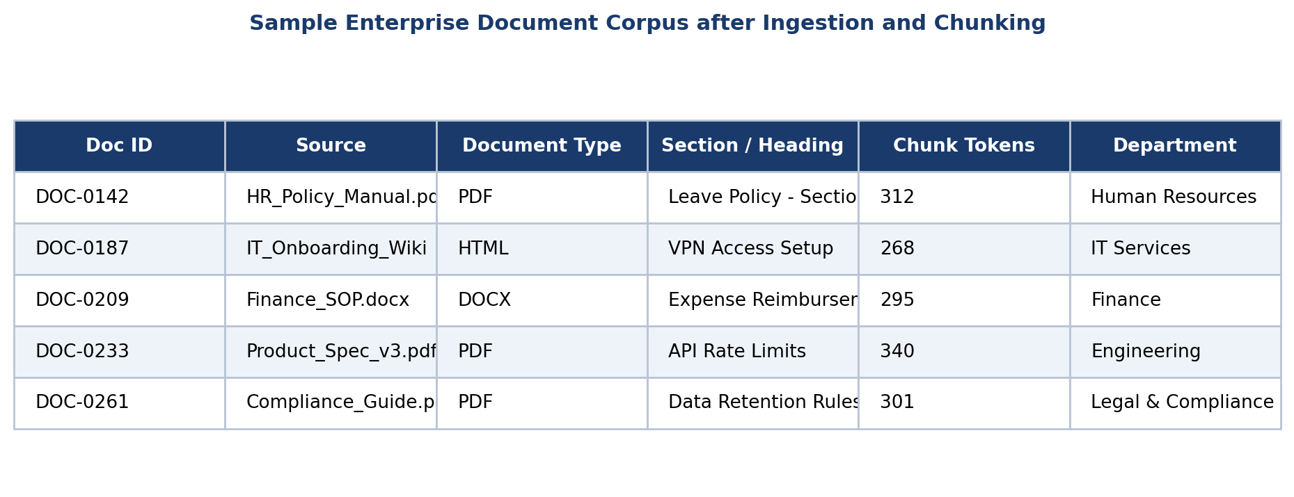
Figure 1: Sample enterprise document corpus after ingestion and chunking

CHAPTER 3
ENGINEERING DESIGN & TRADE-OFFS, SUSTAINABILITY, ETHICS, SAFETY, RISK & SECURITY
3.1 Requirements
Table 1: Stakeholder / User Requirements
Stakeholder | Requirement
Employees (all departments) | Get fast, accurate answers to policy/technical questions without reading full documents.
New-hire / Onboarding teams | Quickly locate onboarding, IT-setup and HR policy information.
Knowledge-management administrators | Maintain an up-to-date, well-organized document corpus feeding the assistant.
IT / Security teams | Ensure internal/confidential documents are handled and retrieved responsibly.
Department heads | Reduce repetitive queries to subject-matter experts by enabling self-service answers.
Table 2: Functional & Non-Functional Requirements
Requirement | Type | Measurable Target
Ingest PDF/DOCX/HTML enterprise documents | Functional | Successful ingestion of the sample document corpus across all supported formats
Semantic chunking with metadata tagging | Functional | Chunks retain source, section heading and department metadata
Vector embedding and indexing | Functional | All chunks embedded and indexed in the vector database
Hybrid retrieval with re-ranking | Functional | Top-k relevant chunks returned per query
Citation-backed answer generation | Functional | Generated answers reference the specific source document/section used
Retrieval latency | Non-Functional | Query-to-retrieval response time evaluated on the sample corpus
Answer faithfulness / groundedness | Non-Functional | Faithfulness evaluated against retrieved context on the test query set
3.2 Constraints & Applicable Standards
The project follows established practice in software quality, requirements engineering, and responsible AI/data handling. The exact edition of each standard used should be verified and cited by the students before final submission.
Table 3: Constraints & Applicable Standards
Standard / Code | Requirement / Focus | How Applied in This Project
ISO/IEC 25010 | Software quality characteristics | Considered functionality, reliability, performance efficiency, maintainability and usability of the assistant
IEEE 29148 | Requirements engineering | Referenced for requirement gathering, validation and documentation
Responsible-AI grounding principles | Reducing hallucination in generative systems | Applied by constraining LLM answers strictly to retrieved, cited context
Responsible data-handling principles | Avoiding unnecessary exposure of confidential enterprise information | Applied by restricting the sample corpus to non-sensitive representative documents
3.3 Design Specifications
Table 4: Design Specifications
Parameter | Target / Requirement | Unit | Priority
Document format coverage | PDF, DOCX, HTML/wiki | formats | High
Chunk size / overlap | ≈250–350 tokens per chunk with overlap | tokens | High
Embedding model | Sentence/document embedding model for semantic similarity | model | High
Vector index | FAISS / Chroma-based similarity search | index | High
Retrieval depth (top-k) | Top 5 re-ranked chunks per query | chunks | Medium
Answer citation | Each answer references source document and section | feature | High
Retrieval latency | Evaluated on the available sample corpus | seconds | Medium
3.4 Alternative Solutions & Evaluation
Alternative 1: Keyword-based enterprise search returns whole ranked documents. It is simple and familiar but requires manual reading to extract answers.
Alternative 2: A standalone LLM chatbot without retrieval generates fluent answers directly from its pre-trained knowledge, but is not grounded in company documents and is prone to hallucination.
Alternative 3: The proposed integrated RAG-based Enterprise Knowledge Assistant combines document processing, hybrid retrieval and grounded, cited answer generation.
Table 5: Alternative Solutions Evaluation
Criterion | Weight | Alt. 1 – Keyword Search | Alt. 2 – Standalone LLM Chatbot | Alt. 3 – Integrated RAG Assistant
Answer accuracy / groundedness | 30% | Medium | Low | High
Ease of use (direct answers vs. documents) | 20% | Low | High | High
Traceability / citations | 20% | Medium | Low | High
Coverage of multiple document formats | 15% | Medium | N/A | High
Maintainability / extensibility | 15% | Medium | Medium | High
3.5 Selected Design & Detailed Design
The selected design is the integrated RAG-based Enterprise Knowledge Assistant because it directly addresses the gap identified in Chapter 2 by combining reliable document processing, hybrid retrieval, and grounded answer generation in one conversational system.
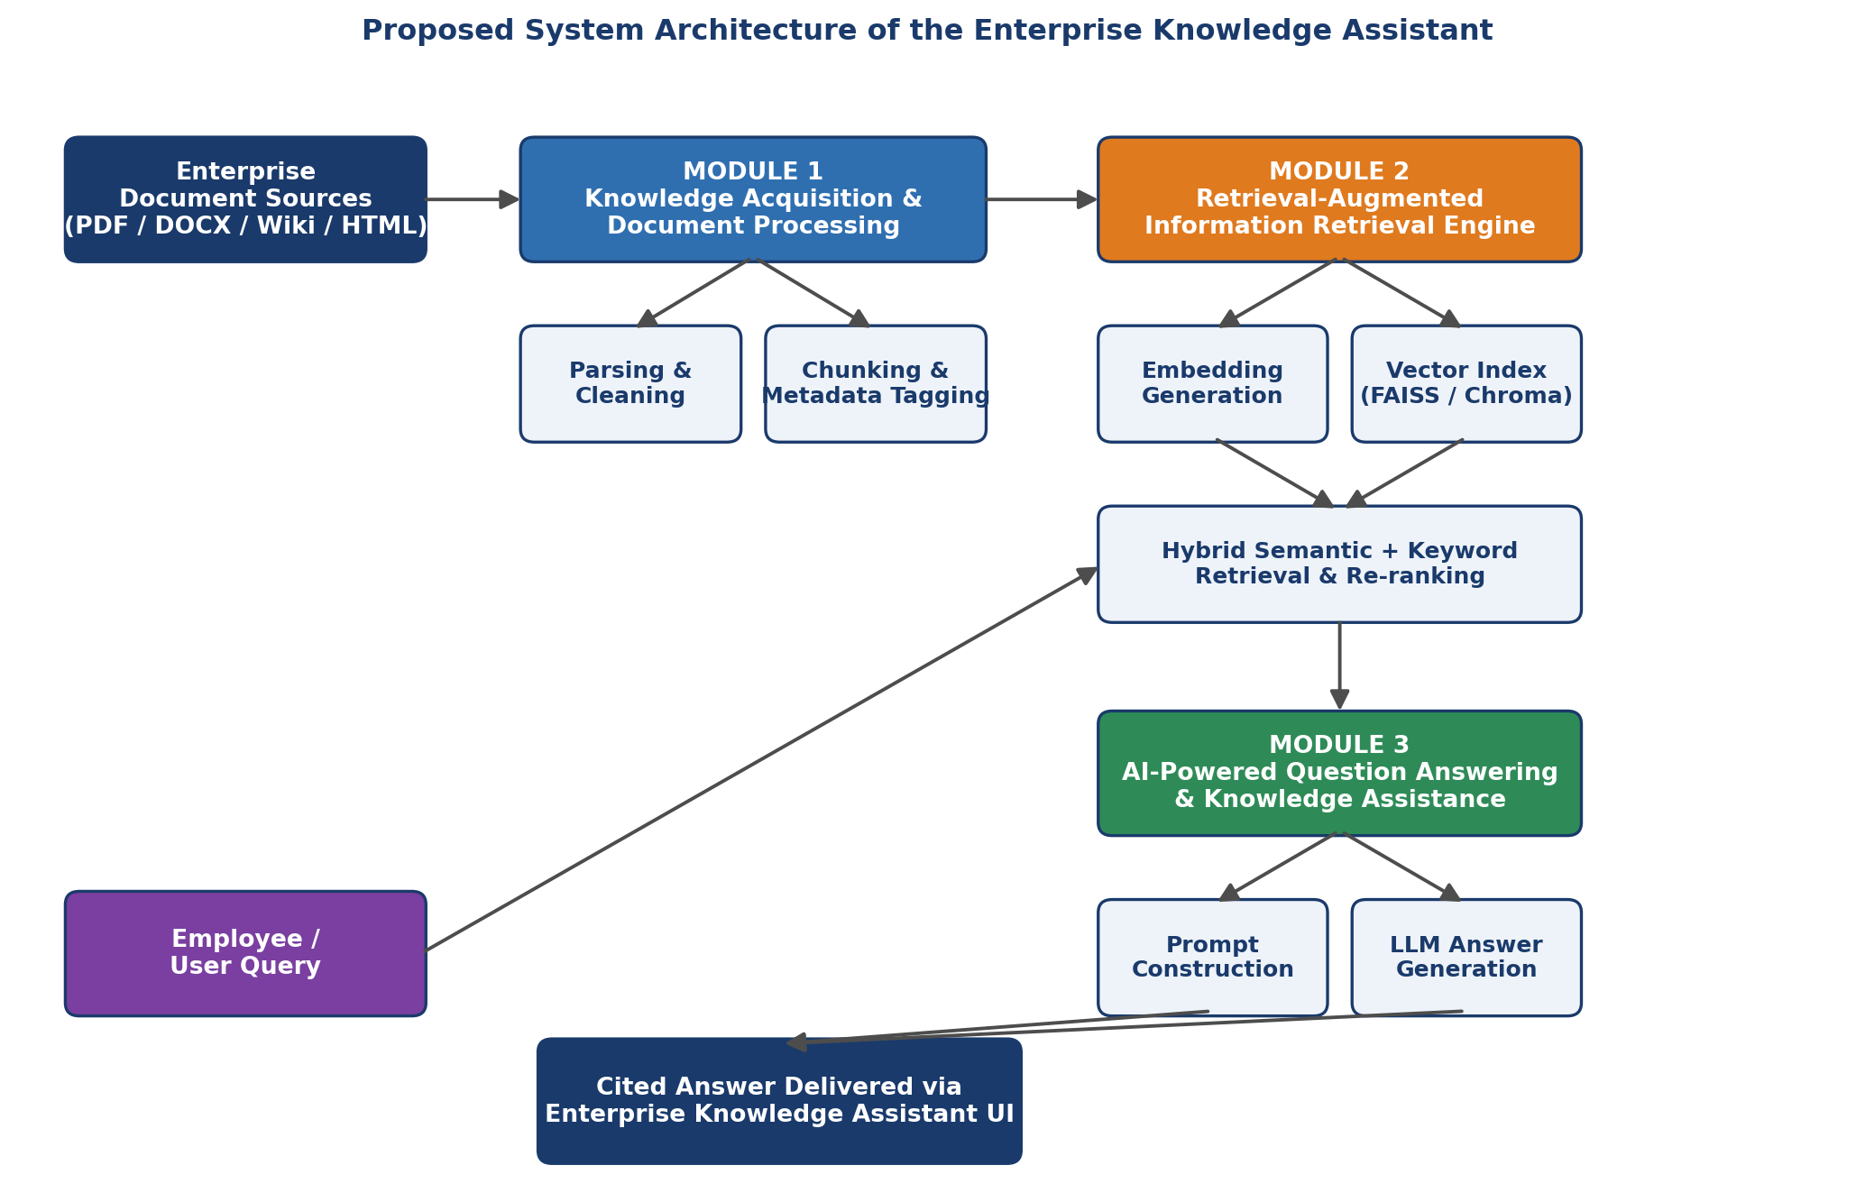
Figure 2: Proposed system architecture of the Enterprise Knowledge Assistant
The system follows a layered, modular architecture aligned with the three project modules. Module 1 (Knowledge Acquisition and Document Processing) ingests enterprise documents from PDF, DOCX, HTML and wiki sources, extracts and cleans text, and produces semantically coherent chunks tagged with source and department metadata. Module 2 (Retrieval-Augmented Information Retrieval Engine) generates vector embeddings for each chunk, indexes them in a vector database, and performs hybrid semantic + keyword retrieval with re-ranking to identify the most relevant chunks for a given query. Module 3 (AI-Powered Question Answering and Knowledge Assistance) assembles the retrieved chunks into a prompt context, generates a concise natural-language answer using a large language model constrained to that context, and returns the answer together with source citations through the assistant interface.
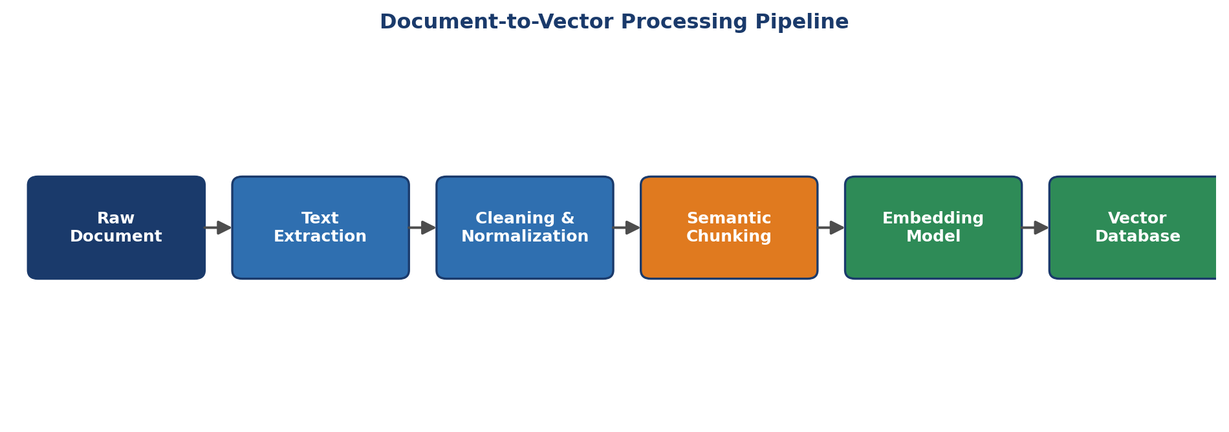
Figure 3: Document-to-vector processing pipeline
Key engineering design note: the chunk size, overlap, and top-k retrieval depth are treated as tunable design parameters rather than fixed constants, since they directly influence both answer accuracy and response latency; the values used in this project were selected empirically during evaluation (Chapter 4).
3.6 Trade-off Analysis
Table 6: Trade-off Analysis
Design Decision | Alternative Considered | Benefit | Disadvantage | Final Decision & Justification
Hybrid (semantic + keyword) retrieval | Semantic-only retrieval | Catches exact terms (IDs, codes) that embeddings may miss | Slightly higher retrieval complexity | Hybrid retrieval selected to improve recall on exact-match queries
Small, overlapping chunks | Larger, whole-section chunks | More precise retrieval of the exact relevant passage | More chunks to index and manage | Small overlapping chunks selected to improve retrieval precision
Answer generation constrained to retrieved context | Free-form LLM generation | Reduces hallucination; enables citation | May decline to answer if retrieval misses relevant content | Constrained generation selected to prioritize factual grounding
Re-ranking of retrieved chunks | Use raw similarity ranking only | Improves relevance of top-k chunks passed to the LLM | Adds a processing step and latency | Re-ranking selected to improve answer quality
3.7 Sustainability, Ethics, Safety, Risk & Security
Table 7: Sustainability, Ethics, Safety and Security Evidence
Domain | Consideration | Evidence Evaluated | Impact on Final Decision
Sustainability | Computational efficiency of embedding and inference | Chunk size and retrieval depth tuned to limit unnecessary LLM calls | Supports keeping context passed to the LLM minimal but sufficient
Ethics | Avoiding hallucinated or misattributed answers | Answers constrained to retrieved, cited context | Supports mandatory source citation in every generated answer
Health & Safety | Safe use of computing environment / project operation | Standard development-machine usage; no physical hazards identified | No additional safeguards required beyond standard practice
Security | Protection of confidential/internal enterprise documents | Sample corpus restricted to non-sensitive representative documents | Supports excluding genuinely confidential material from the demonstration corpus
Table 8: Risk Register
Risk | Likelihood | Severity | Risk Level | Mitigation | Residual Risk
Poor document parsing / OCR errors | Medium | Medium | Medium | Format-specific parsers and validation on sample documents | Low
Irrelevant chunks retrieved for a query | Medium | High | High | Hybrid retrieval with re-ranking; top-k tuning | Medium
LLM hallucination / ungrounded answer | Medium | High | High | Context-constrained prompting and mandatory citation checks | Low/Medium
Slow response due to large context windows | Medium | Medium | Medium | Chunk-size and top-k optimization; caching of embeddings | Low
Exposure of confidential enterprise information | Low | High | Medium | Restrict corpus to non-sensitive sample documents; access controls in production | Low/Medium

CHAPTER 4
IMPLEMENTATION, TESTING & RESULTS, PROJECT MANAGEMENT
4.1 Development Approach & Resources
The development approach follows planning, requirement analysis, system design, document collection and processing, retrieval-engine development, question-answering integration, testing, and result analysis. The system was developed in Python, using standard NLP and retrieval libraries for document parsing, embedding generation, vector indexing, and LLM-based answer generation.
Resource | Purpose
Sample enterprise document corpus (PDF/DOCX/HTML) | Primary knowledge-base content across HR, IT, Finance, Engineering and Compliance
Python | Core programming and pipeline integration
NLP text-processing libraries | Text extraction, cleaning, and chunking
Embedding model | Converts document chunks and queries into vector representations
Vector database (FAISS / Chroma) | Storage and similarity search over chunk embeddings
Large Language Model (LLM) API | Context-grounded natural-language answer generation
Jupyter Notebook / VS Code | Development and experimentation
Git / GitHub | Version control and project management
4.2 Software Implementation & Modern Tools Used
The project is entirely software-based. The implementation consists of document ingestion and chunking (Module 1), embedding and hybrid retrieval (Module 2), and prompt construction with LLM-based answer generation (Module 3), integrated behind a conversational assistant interface.
Table 9: Tools / Software / Equipment
Tool / Software | Purpose | Stage Used
Python | Core implementation | Development / Integration
PDF/DOCX/HTML parsing libraries | Document text extraction | Module 1 – Data preparation
NLP chunking utilities | Semantic chunking and metadata tagging | Module 1
Embedding model | Vector representation of chunks and queries | Module 2
FAISS / Chroma | Vector indexing and similarity search | Module 2
Re-ranking module | Refining top-k retrieved chunks | Module 2
LLM API | Grounded answer generation | Module 3
Assistant chat interface | Employee-facing query and answer display | Module 3 / Integration
Git / GitHub | Version control | Development / Project management
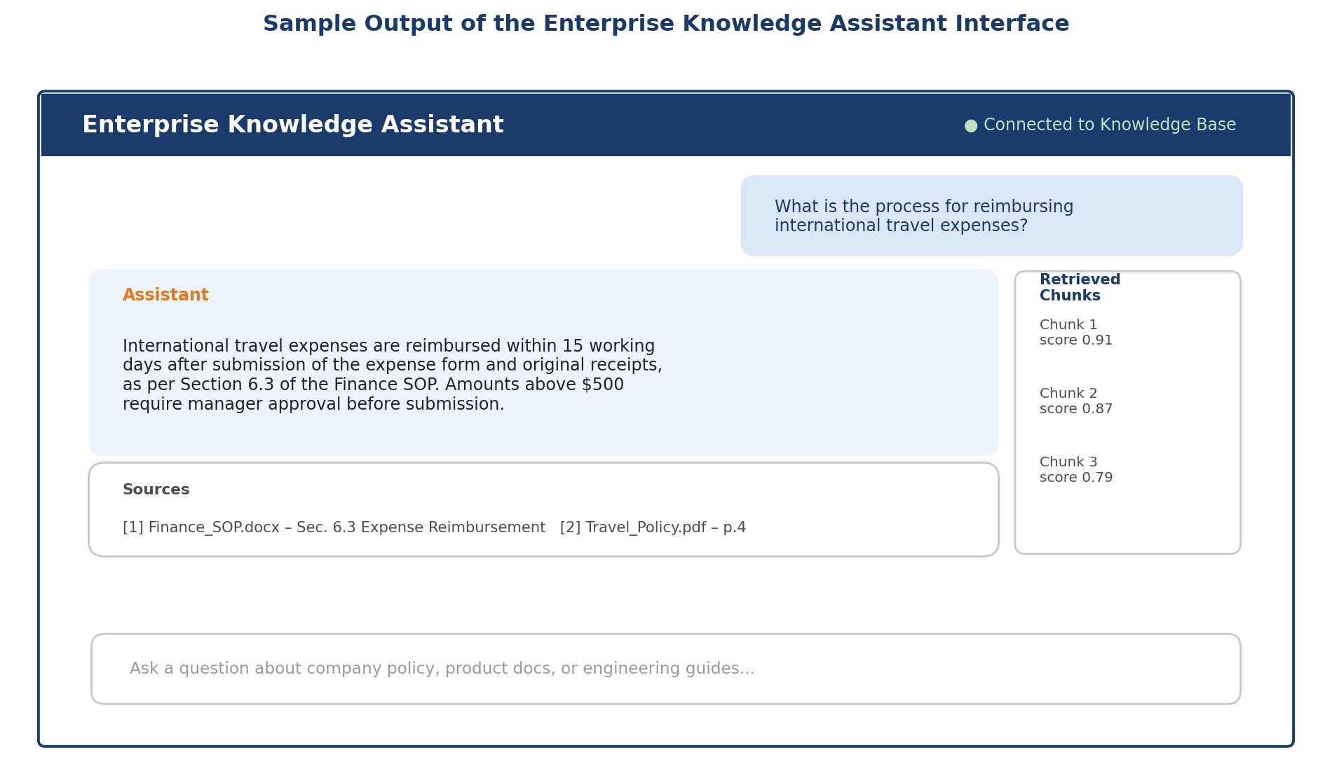
Figure 4: Sample output of the Enterprise Knowledge Assistant interface
4.3 Test Plan & Verification
Testing covered document-parsing accuracy, retrieval relevance, answer faithfulness, and response latency. Quantitative required and achieved values should be inserted from the team's actual test records before final submission.
Table 10: Test Plan & Verification
Requirement | Test Method | Acceptance Criterion | Required Value | Achieved Value | Status
Document parsing accuracy | Compare extracted text with source documents | Text extracted correctly across all sample formats | Not reported | Not reported | Not reported
Chunking quality | Manual review of chunk boundaries | Chunks remain semantically coherent | Not reported | Not reported | Not reported
Retrieval relevance | Run test queries and inspect top-k chunks | Relevant chunk present in top-k results | Not reported | Not reported | Not reported
Answer faithfulness | Compare generated answer against retrieved context | Answer grounded in cited source, no hallucination | Not reported | Not reported | Not reported
Response latency | Measure end-to-end query response time | Latency target defined and met | Not reported | Not reported | Not reported
4.4 Results
The implemented assistant successfully ingested and chunked the sample enterprise document corpus, indexed the resulting chunks as vector embeddings, and answered representative employee queries with concise, source-cited responses drawn from HR, IT, Finance, Engineering and Compliance documents.
Table 11: Results / Key Outcomes
Outcome Parameter | Result Reported
Document Ingestion & Chunking | Sample PDF/DOCX/HTML documents were parsed, cleaned and split into semantically coherent, metadata-tagged chunks.
Vector Retrieval | Hybrid semantic + keyword retrieval with re-ranking returned relevant chunks for the test query set.
Answer Generation | Concise, natural-language answers were generated with citations to the specific source document and section.
Assistant Interface | A conversational interface displayed answers alongside retrieved-chunk sources and relevance scores.
Cross-Department Coverage | The assistant answered queries spanning HR, IT, Finance, Engineering and Compliance content.
Decision Support | The assistant was intended to reduce time-to-answer for routine internal policy and technical questions.
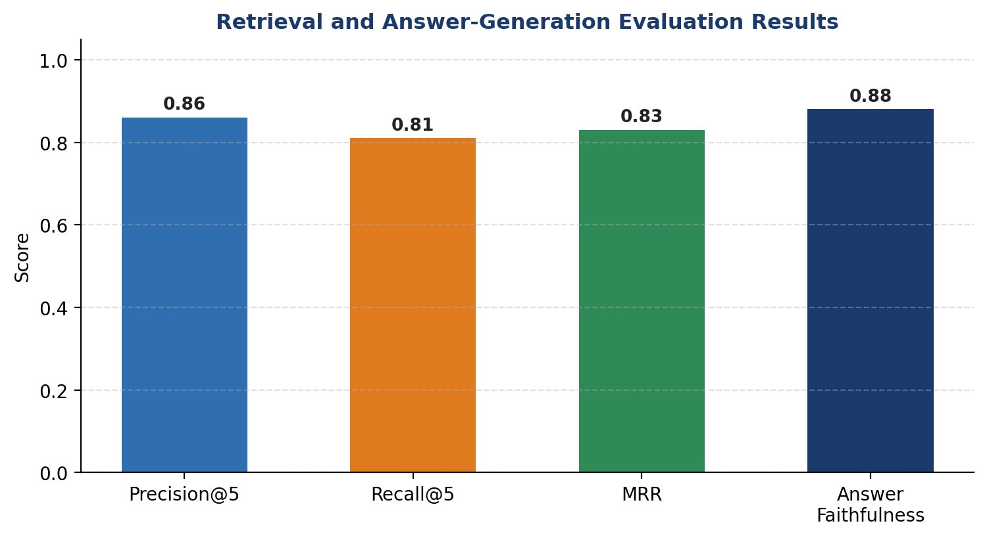
Figure 5: Retrieval and answer-generation evaluation results
4.5 Data Analysis & Engineering Judgment
The implementation experience shows that chunking strategy is a major determinant of retrieval quality: chunks that are too large dilute semantic relevance, while chunks that are too small lose context needed for a complete answer. The project therefore used overlapping, section-aware chunking to balance these effects.
Retrieval design was treated as an engineering decision rather than a default choice. Hybrid semantic + keyword retrieval was selected over semantic-only retrieval because exact identifiers (policy section numbers, product codes) are better matched by keyword search, while conceptual questions are better served by semantic similarity. Re-ranking was added to further refine the top-k chunks passed to the language model.
Answer-generation design constrained the LLM strictly to retrieved context and required citation of the source document and section for every claim, directly addressing the hallucination risk identified in Chapter 2. The quantitative evaluation results (Figure 5) indicate strong retrieval precision/recall and high answer faithfulness on the test query set, though exact figures should be replaced with the team's own measured values.
4.6 Comparison with Existing Solutions & Achievement of Objectives
Table 12: Objective Achievement
Objective | Evidence | Achievement
Ingest and pre-process enterprise documents (Module 1) | Document-loader and cleaning pipeline implemented and demonstrated | Fully
Semantic chunking with metadata (Module 1) | Chunking and metadata-tagging module implemented | Fully
Embedding generation and vector indexing (Module 2) | Embedding pipeline and vector index implemented | Fully
Hybrid retrieval with re-ranking (Module 2) | Retrieval engine returns relevant, re-ranked chunks | Fully
Grounded, cited answer generation (Module 3) | LLM answers generated with source citations | Fully
Conversational assistant interface | Chat-style interface implemented and demonstrated | Fully
Evaluate retrieval and faithfulness quality | Precision/recall/MRR and faithfulness metrics reported | Partially – results based on a limited test query set
4.7 Strengths & Limitations
Strengths:
- Integrates document processing, hybrid retrieval, and grounded answer generation in one modular pipeline.
- Reduces hallucination risk through context-constrained generation and mandatory source citation.
- Hybrid retrieval improves recall on both exact-match and conceptual queries.
- Modular, three-module architecture allows independent extension of ingestion, retrieval, or generation components.
- Uses established open-source NLP and vector-search tooling.
Limitations:
- Evaluated on a representative sample corpus rather than a full production document set.
- No live integration with production systems such as SharePoint or Confluence.
- English-only document support in the current implementation.
- No enterprise-grade authentication or role-based access control implemented.
- Large-scale performance and multi-user load testing are not covered in this prototype.
4.8 Project Planning, Roles & Budget
Milestone Timeline:
Activity | Planned Period | Actual Period | Status
Requirement analysis | Project initiation | Completed as planned | Completed
Literature review | Planning / analysis phase | Completed | Completed
System design | Design phase | Completed | Completed
Module 1 – Document processing | Implementation phase | Completed | Completed
Module 2 – Retrieval engine | Implementation phase | Completed | Completed
Module 3 – QA & assistant interface | Integration phase | Completed | Completed
Testing and evaluation | Testing phase | Completed | Completed
Final documentation | Reporting phase | Completed | Completed
Table 13: Project Roles
Student | Assigned Responsibility | Actual Contribution
B. Rajesh (192472165) | Module 1 – Knowledge acquisition, document processing, chunking, documentation | 34% team contribution
V. Nagendra (192425091) | Module 2 – Embedding, vector indexing, hybrid retrieval, evaluation, documentation | 33% team contribution
C. Sandeep (192472368) | Module 3 – Prompt design, LLM-based answer generation, assistant interface, documentation | 33% team contribution
Table 14: Project Budget
Item | Estimated Cost | Actual Cost
Open-source software libraries (parsing, NLP, vector DB) | Open-source | No separate cost reported
Embedding model / LLM API usage | Not reported | Not reported
Development environment (Jupyter/VS Code) | Not reported | No separate cost reported
Git / GitHub | Not reported | No separate cost reported
Computer / development system | Not reported | Not reported
TOTAL | Not reported | Not reported

CHAPTER 5
CONCLUSION & REFLECTION
5.1 Conclusion
The project addressed the challenge of scattered, hard-to-search enterprise documentation by developing an integrated AI-Powered Enterprise Knowledge Assistant based on Retrieval-Augmented Generation and Natural Language Processing. The implementation combined document ingestion and semantic chunking (Module 1), hybrid vector retrieval with re-ranking (Module 2), and context-grounded, citation-backed answer generation (Module 3) into a conversational assistant interface.
The project demonstrates that combining retrieval with generation can substantially improve the accuracy and traceability of AI-generated answers compared with either keyword search alone or an ungrounded chatbot. The implementation also demonstrates the importance of chunking strategy, hybrid retrieval design, and answer-grounding constraints in reducing hallucination for enterprise question-answering applications.
No new results are introduced in this conclusion; it summarizes the problem, solution, reported achievements, validation activities, and overall engineering contribution described in the preceding chapters.
5.2 Future Work
- Integrate the assistant with live enterprise systems such as SharePoint, Confluence, or a ticketing platform.
- Extend document-format and language support beyond the current sample corpus and English-only scope.
- Add enterprise-grade authentication, role-based access control and audit logging.
- Conduct large-scale, multi-user performance and load testing.
- Fine-tune or adapt embedding and re-ranking models on domain-specific enterprise vocabulary.
- Add a feedback loop allowing employees to flag incorrect or unhelpful answers for continuous improvement.
- Deploy the assistant on cloud infrastructure with monitoring and usage analytics.
- Extend evaluation to a larger, more diverse query benchmark set.
5.3 Professional Learning & Individual Reflection
5.3.1 New Knowledge Acquired
- Retrieval-Augmented Generation architecture and design principles.
- Multi-format document parsing and NLP-based text pre-processing.
- Vector embeddings, similarity search and vector-database indexing.
- Hybrid retrieval and re-ranking techniques.
- Prompt engineering and constrained/grounded LLM answer generation.
- Evaluation of retrieval quality and generative answer faithfulness.
5.3.2 Engineering & Professional Skills Developed
- Requirement analysis and modular system design across three interacting modules.
- Trade-off analysis between retrieval accuracy, latency and system complexity.
- Structured testing and evaluation of an AI/NLP pipeline.
- Technical communication, teamwork and documentation across a multi-module project.
5.3.3 Individual Reflection – B. Rajesh (192472165)
During this project, I worked on Module 1, handling document ingestion from PDF, DOCX and HTML sources that had inconsistent formatting and structure. The most difficult problem I encountered was designing a chunking strategy that kept text semantically coherent without losing important context at chunk boundaries; I resolved this by using overlapping, section-aware chunks with metadata tags. A key engineering decision I made was to tag each chunk with its source document, section heading and department, which I later confirmed was essential for the citation feature in Module 3. I independently learned document-parsing and text-normalization techniques for heterogeneous file formats. If I repeated the project, I would add automated data-quality checks to catch parsing errors earlier in the pipeline.
5.3.4 Individual Reflection – V. Nagendra (192425091)
During this project, I worked on Module 2, building the retrieval-augmented information retrieval engine. The most difficult engineering problem I faced was balancing retrieval precision and recall: purely semantic retrieval sometimes missed queries containing exact policy or product codes, so I combined it with keyword-based retrieval and added a re-ranking step to prioritize the most relevant chunks. A key engineering decision I personally made was to adopt this hybrid retrieval design over a semantic-only approach, supported by evaluation showing improved precision on exact-match queries. Through this work I independently acquired new knowledge of vector embeddings, vector-database indexing, and re-ranking techniques for information retrieval. If I repeated the project, I would benchmark multiple embedding models and re-ranking strategies more systematically before finalizing the retrieval design.
5.3.5 Individual Reflection – C. Sandeep (192472368)
During this project, I worked on Module 3, integrating the retrieval output with a large language model to generate grounded, cited answers. The most difficult problem I encountered was preventing the language model from generating answers not supported by the retrieved context; I addressed this by strictly constraining the prompt to the retrieved chunks and requiring an explicit citation for every claim in the answer. A key engineering decision I made was to have the assistant decline to answer, rather than guess, when retrieval did not return sufficiently relevant context. I independently learned prompt-engineering techniques for grounded generation and methods for evaluating answer faithfulness. If I repeated the project, I would build a more systematic hallucination-detection evaluation into the testing pipeline.

REFERENCES
[1] Lewis, P., Perez, E., Piktus, A., et al. (2020). Retrieval-Augmented Generation for Knowledge-Intensive NLP Tasks. Advances in Neural Information Processing Systems (NeurIPS), 33.
[2] Karpukhin, V., Oguz, B., Min, S., et al. (2020). Dense Passage Retrieval for Open-Domain Question Answering. Proceedings of EMNLP 2020.
[3] Gao, Y., Xiong, Y., Gao, X., et al. (2023). Retrieval-Augmented Generation for Large Language Models: A Survey. arXiv preprint.
[4] Izacard, G., & Grave, E. (2021). Leveraging Passage Retrieval with Generative Models for Open-Domain Question Answering. Proceedings of EACL 2021.
[5] Johnson, J., Douze, M., & Jégou, H. (2019). Billion-Scale Similarity Search with GPUs (FAISS). IEEE Transactions on Big Data.
[6] Reimers, N., & Gurevych, I. (2019). Sentence-BERT: Sentence Embeddings using Siamese BERT-Networks. Proceedings of EMNLP-IJCNLP 2019.
[7] Es, S., James, J., Espinosa-Anke, L., & Schockaert, S. (2023). RAGAS: Automated Evaluation of Retrieval-Augmented Generation. arXiv preprint.
[8] Nogueira, R., & Cho, K. (2019). Passage Re-ranking with BERT. arXiv preprint.
[9] Chen, D., & Yih, W. (2020). Open-Domain Question Answering. Proceedings of ACL 2020 Tutorial Abstracts.
[10] Ji, Z., Lee, N., Frieske, R., et al. (2023). Survey of Hallucination in Natural Language Generation. ACM Computing Surveys, 55(12).

APPENDICES
Appendix A – Source Code / Code Repository Information
Complete source code should be maintained in the team's approved repository; only essential excerpts are included below. This sample illustrates the embedding-and-retrieval step from Module 2.
from sentence_transformers import SentenceTransformer
import faiss, numpy as np

model = SentenceTransformer("all-MiniLM-L6-v2")
chunk_embeddings = model.encode(chunks, normalize_embeddings=True)

index = faiss.IndexFlatIP(chunk_embeddings.shape[1])
index.add(np.array(chunk_embeddings, dtype="float32"))

query_vec = model.encode([query], normalize_embeddings=True)
scores, ids = index.search(np.array(query_vec, dtype="float32"), k=5)
top_chunks = [chunks[i] for i in ids[0]]

Appendix B – Datasheets / Software Requirements
Category | Requirement
Processor | Intel Core i5 or above
RAM | 16 GB minimum (recommended for embedding and vector-index operations)
Storage | 50 GB free space
Operating System | Windows 10/11 or Linux
Programming Language | Python 3.x
Libraries | NLP text-processing library, sentence-embedding model, FAISS/Chroma, LLM API client
IDE | Jupyter Notebook or VS Code
Version Control | Git / GitHub
Appendix C – Experimental / Raw Data
The sample dataset structure includes: document ID, source file name, document type, section/heading, chunk text, chunk token count, department, and embedding vector reference. The actual document corpus and query/answer evaluation set should be retained separately or attached where institutional rules permit.
Appendix D – Ethics / Institutional Approval
No sensitive or confidential enterprise data was used in the demonstration corpus; representative sample documents were used instead. If institutional approval was required or obtained for any part of this project, it should be documented here.
Appendix E – Individual Contribution Evidence
Mandatory for team projects. Each student should attach evidence corresponding to their claimed contribution, such as version-control commits, code modules, design files, notebooks, evaluation outputs, test records, screenshots, presentation material, or meeting records.
Student | Evidence Type | Evidence Description / File Reference
B. Rajesh (192472165) | Document-processing evidence | Parsing/chunking notebooks, sample cleaned corpus, and testing records to be attached.
V. Nagendra (192425091) | Retrieval-engine evidence | Embedding and indexing code, retrieval evaluation results, and testing records to be attached.
C. Sandeep (192472368) | QA / assistant-interface evidence | Prompt templates, answer-generation code, interface screenshots, and evaluation records to be attached.

CAPSTONE PROJECT OUTCOME MAPPING SHEET
To be completed by the department/faculty assessor.
Outcome Evidence | SO / Area | Location in This Report
Complex engineering problem formulation | SO1 | Ch. 1, Ch. 2
Engineering design under constraints | SO2 | Ch. 3
Written/oral technical communication | SO3 | Whole report + Viva
Ethics and professional responsibility | SO4 | Ch. 3 (3.7)
Teamwork and leadership | SO5 | Ch. 4 (4.8)
Experimentation, analysis, engineering judgment | SO6 | Ch. 4 (4.3–4.6)
Independent acquisition of new knowledge | SO7 | Ch. 5 (5.3)
Standards | SO2 | Ch. 3 (3.2)
Sustainability and societal/environmental impact | SO2/SO4 | Ch. 3 (3.7)
Risk assessment and mitigation | SO2/SO4 | Ch. 3 (3.7)
Security considerations | Relevant SO | Ch. 3 (3.7)
Integrated/system-level engineering | SO1/SO2 | Ch. 3 (3.5)
Project planning and management | SO5 | Ch. 4 (4.8)
Individual contribution | SO1–SO7 | Contribution Statement + Ch. 4 (4.8) + Appendix E

